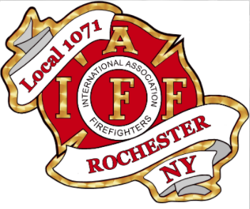

Rochester Fire Fighters Local 1071 was founded in 1950 and currently represents 482 Active Fire Fighters of the Rochester Fire Department.   
  
The men and women of Rochester Fire Fighters Local 1071 are highly trained to respond to various incidents including fire suppression, EMS, Fire Investigation, hazardous materials, rope rescue, structural collapse, confined space, swift water rescue, ice rescue, and accident victim extrication. In addition, our members provide fire prevention and fire safety education and training, operate a smoke detector installation program and are available to the citizens of Rochester 24 hours a day, 365 days a year.  
  
The members of Local 1071 are also involved in many charities; Muscular Dystrophy Association, Retired Professional Fire Fighters Cancer Fund, Operation Warm, and many others.  
  
Rochester Fire Fighters Local 1071 is also active in supporting programs and legislation that directly impacts the Health & Safety of Fire Fighters. Our Political Action Committee continues to maintain a Bi-Partisan position with a belief and policy that we support those who support Fire Fighters. As well as being members of the International Association of Fire Fighters (IAFF) we are members of the NY State Professional Fire Fighters Association (NYSPFFA), Rochester Labor Council and the AFL-CIO.  
  
Our Mission: The object of this Local is to give voice to our members, to improve their morale, intellectual, social and economic conditions. To consider the sick, and respect the dead, to promote skill and pride in our work, to promote cordial relations with everyone we contact or serve, to promote social, charitable, and athletic activities, and promote health and safety practices.

Rochester Fire Fighters Local 1071

Scholarship

Rochester Fire Fighters Local 1071

Rochester Fire Fighters Association Local 1071 Scholarship fund was established as a way to give back to the community that has given so much to the men and woman who serve the Rochester Fire Department. We want to assist the young men and women of this community as they enter this stage of their lives, and together help shape the Rochester youth and community. We want to make a difference in the lives of Rochester’s youth, one child at a time, in hopes they will someday make a difference in this community we call home. A total of three scholarships will be awarded for a one-time payment of $1000.00 each.

INTRODUCTION

+

+

**APPLICATION REQUIREMENTS:**

Completed application must be submitted to Rochester Fire Fighters Local 1071 Scholarship Committee, 65 Hudson Ave, Rochester, NY 14605 by May 15, 2021. **A completed application must include: a statement from the applicant, two letters of references (one from a school official), an official sealed copy of the applicants transcripts and the checklist page with the applicants signature to the scholarship commitments. Letters of reference must come from someone other than a relative or guardian.**

**ELIGIBILITY:**

The scholarship is open to all seniors graduating from a Rochester City School District High School, or residing in the city of Rochester who followed all the rules, regulations and procedures of his/her school.

**CRITERIA:**

Applicant must demonstrate the ability to succeed in college, technical or trade school, or other post high school advancement program. This is most frequently demonstrated by a grade point average of **2.5** (out of 4.0) or higher and/or excelling in a particular subject area or skill set. Applicant must demonstrate financial need. Other criteria considered include employment or volunteering/assisting others, perseverance, and pursuit of a passion or strong expertise/interest.

Applicants must submit a complete application packet which includes:

* This completed application form with a personal statement/essay
* Two references, one from a school official (Teacher, Coach, Principal, etc). References from a relative or family member are not permissible.
* Acceptance letter from the college, technical or trade school, or other post high school advancement program (may be submitted at the time of award)
* Official, sealed, high school transcripts

Preference will be given to applicants who have submitted a letter of recommendation from an individual who has been positively affected by the applicant e.g. a community or activity sponsor, employer, minister, teacher, peer or child.

**AWARD:**

If selected for the scholarship, the student will be awarded **$1000.00** to go for expenses for college, a technical or trade school, or other post high school advancement programs. A copy of the student’s “Letter of intent” from the college, or post high school advancement program he/she is attending must be submitted prior to disbursement of the funds.

The student who is awarded the scholarship will be required to: submit a picture to be posted on the Rochester Fire Fighters Local 1071 website within a week of notification of the scholarship, and attend a ceremony at the Rochester Fire Fighters Local 1071 building to receive the scholarship. The student must also respond to periodic emails to keep Local 1071 informed of your progress and write a testimonial or be interviewed after the first year of college or the program.

# **Rochester Fire Fighters Local 1071 Scholarship for City of Rochester High School Seniors**

+

**Applicant Name:** *(Last)* *(First)*

**Address:** *(Street)*

*(City) (State) (Zip code)*

**Phone Number:**

**Email Address if Available:**

**High School:**

**Extracurricular activities in which you are involved (including paid employment, volunteer work, sports, and hobbies):**

**Grade Point Average:**

**Number of persons in household (including you):**

**Family Gross income is: (Please Check One Box)**

* Less then $25,000
* $25,000- 45,000
* $45,000- 65,000
* Greater than $65,000

**Expected Family Contributions from FAFSA/SAR:**

**Please list below the college or program you will be attending or have been accepted into. Acceptance letter or letter of intent from the program is required before any award is made.**

**Parent or Legal Guardian:**

**Address:** *(Street)*

*(City) (State) (Zip code)*

**Phone Number:**

**Email address if applicable:**

## 2021 Application Form

## For City of Rochester High School Senior

Please describe in no more than 250-500 words an influential person or event that has occurred in your life, and the influence it has had on you (Typed essay to be included with your application)

PERSONAL STATEMENT/ ESSAY

Pellentesque viverra. Ut sed odio. Class aptent taciti sociosqu ad litora torquent per conubia nostra, per inceptos hymenaeos. Donec porttitor venenatis felis. Vivamus orci. Vestibulum rutrum tincidunt ante.

Integer non sem. Donec enim diam, sagittis at, mattis nec, ultricies vitae, diam. Donec euismod turpis et diam. Nunc non nulla. Duis nec tortor. Nulla facilisi. In ligula lectus, nonummy nec, pulvinar id, pulvinar ac, nisl. Pellentesque purus. Proin tristique tempus turpis. Ut id lectus. Nulla facilisi.

Mauris nonummy turpis id nisl. Fusce sit amet purus. Donec commodo, lorem id sodales congue, nulla lacus commodo mi, vel volutpat tortor augue id quam. Donec sit amet massa. Fusce at nulla. Aenean faucibus odio eget tortor. Pellentesque tellus. Cum sociis natoque penatibus et magnis dis parturient montes, nascetur ridiculus mus. Etiam nisl elit, venenatis consequat, auctor non, sagittis sed, arcu. Sed arcu ipsum, fringilla ac, blandit a, lobortis vel, risus. Proin pulvinar malesuada metus. Pellentesque gravida fermentum nibh. Sed libero neque, feugiat eget, condimentum eu, tempor in, erat. Vestibulum ante ipsum primis in faucibus orci luctus et ultrices posuere cubilia Curae; Pellentesque tristique adipiscing lacus.

Aliquam erat volutpat. Pellentesque vel augue. Suspendisse id quam a tellus laoreet viverra. Sed dignissim mattis ligula. Quisque vel neque vitae purus dapibus tristique. Nullam sed urna. Lorem ipsum dolor sit amet, consectetuer adipiscing elit. estibulum ante ipsum primis in faucibus orci luctus et ultrices posuere cubilia Curae; Sed leo quam, pretium non, blandit eget, tincidunt a, augue. Donec ut massa.

Nam vestibulum dolor quis libero.

### pellentesque:

**Applicant’s Name:**

**Person providing letter of recommendation:**

**Name:**

**Address:**

**City/State/ Zipcode:**

**Contact Information:**

**Work Phone Number:**

**Personal Phone Number:**

**Email Address:**

**How do you know the applicant?**

**How long have you known the applicant?**

**Highest grade point average a student can attain at your High School?**

**Why should the applicant be considered for this scholarship? Please state examples of the applicant’s ability to work at the college level or excel in another post high school advancement program (Typed responses are preferred):**

LETTER OF RECOMMENDATION FORM

REFERENCE 1: FROM SCHOOL OFFICIAL

+

**Applicant’s Name:**

**Person providing letter of recommendation:**

**Name:**

**Address:**

**City/State/ Zipcode:**

**Contact Information:**

**Work Phone Number:**

**Personal Phone Number:**

**Email Address:**

**How do you know the applicant?**

**How long have you known the applicant?**

**Why should the applicant be considered for this scholarship? Please state examples of the applicant’s ability to work at the college level or excel in another post high school advancement program (Typed responses are preferred):**

# LETTER OF RECOMMENDATION FORM

# REFERENCE 2

+

**CHECKLIST:**

* Completed application form
* Applicant personal statement/essay
* Recommendation one (from school official)
* Recommendation two
* Completed commitment statement, on this page
* Official, sealed, high school transcripts
* Letter of intent to enter college or post high school advancement program (with initial application, or by June 10 **at the latest)**

**APPLICANTS COMMITMENT STATEMENT:**

If awarded the scholarship, I will provide a picture within 7 days of notification of the award, receive the scholarship in person, and agree to be photographed. Photographs may be used in the organization’s materials and on its website to help increase its ability to help additional kids. I agree to respond to periodic emails during the year to provide updates on my progress and to write a testimonial or participate in an interview at the end of the first academic or program year

Print Name:

Signature:

Date:

Rules governing scholarship assistance are as follows:

1. No distinction as to race, color, creed, sex, rank of parent/legal guardian, association with City of Rochester or Rochester Fire Fighters Local 1071 shall be drawn in granting of scholarships.

2. The candidate must be a graduating high school senior in 2021.

3. The candidate must be accepted at an accredited post secondary institution.

4. No assistance will be provided to any student who is already receiving or anticipates receiving a fully paid scholarship, grant or financial aid package (Not including repayable loans).

5. No request for assistance will be considered until the candidate has provided a complete application. Failure to complete the application in full and submit by deadline will result in disqualification.

6. Scholarships will be paid directly to the applicant and will be used towards school related expenses such as tuition, books, room and board, etc.

7. All scholarships are a onetime payment for the first year of attendance.

8. Completed applications must be post marked no later than May 15, 2021

9. No member may serve on the scholarship selection committee who has a child/relative applying for this scholarship.

Any questions please contact [Scholarship.IAFF1071@gmail.com](mailto:Scholarship.IAFF1071@gmail.com) for guidance.

SCHOLARSHIP CHECKLIST:

*To be submitted with application*

+

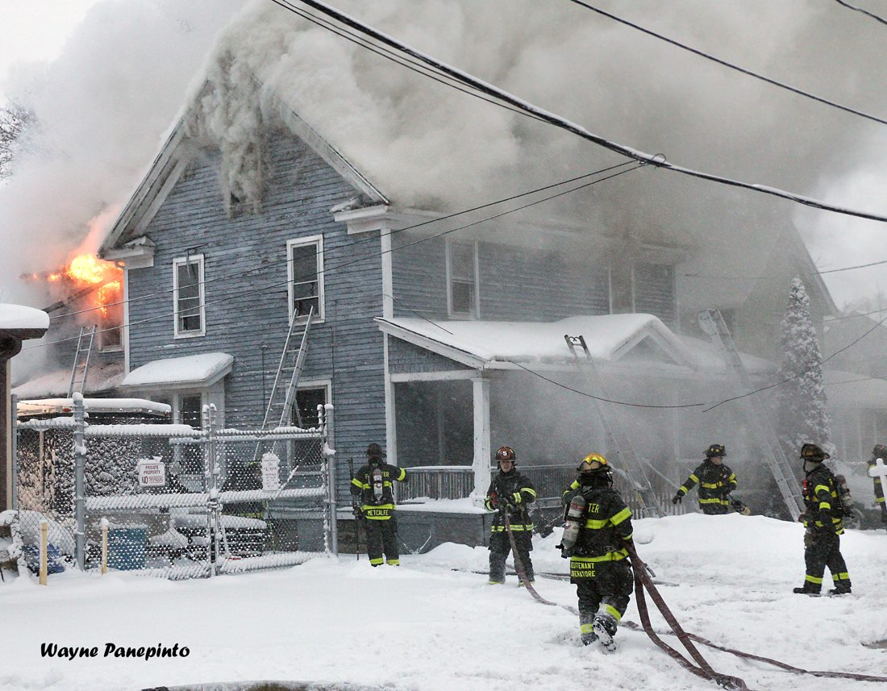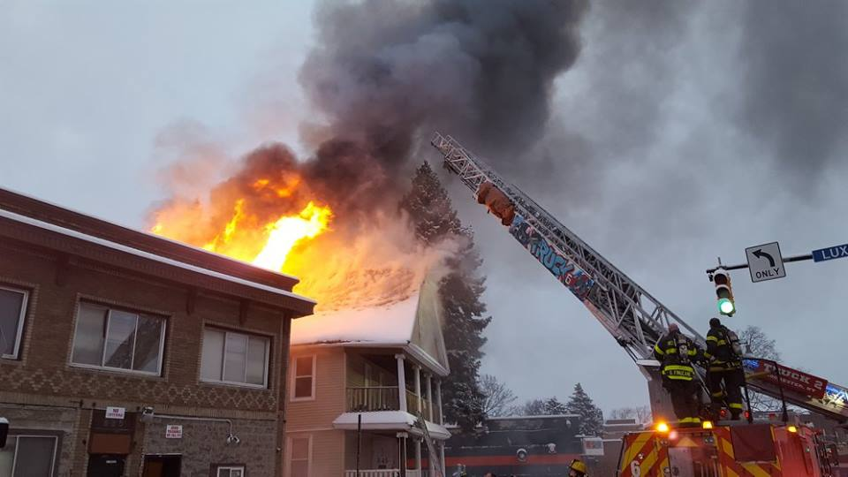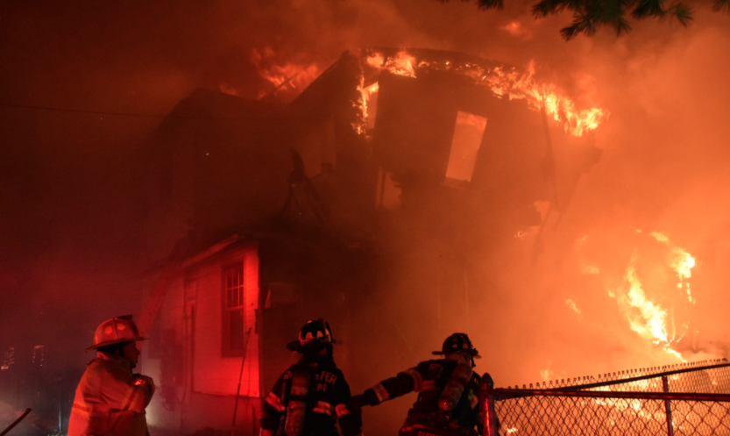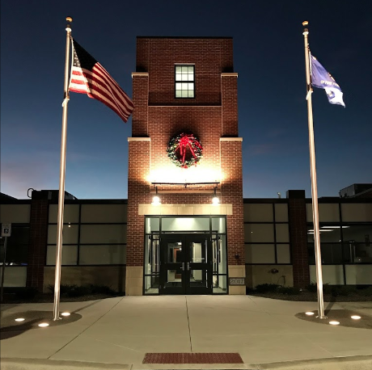

Rochester Fire Fighters Local 1071

65 HUDSON AVE.   
ROCHESTER, NY 14605

(585) 458 – 9250

iaff1071.org

+

**ROCHESTER FIRE FIGHTERS LOCAL 1071**

+